Task: Install Apache Tomcat on Port Number 8082

Step-by-Step Implementation

1. Start Your Ubuntu VM
Start your Ubuntu virtual machine in VMware and log in to your Ubuntu system.

2. Open a Terminal
Press Ctrl + Alt + T to open the terminal.

3. Update the Package List and Install Java
Apache Tomcat requires Java to run. Update the package list and install Java:
sudo apt update
sudo apt install openjdk-17-jdk -y
Verify the Java installation:
java –version
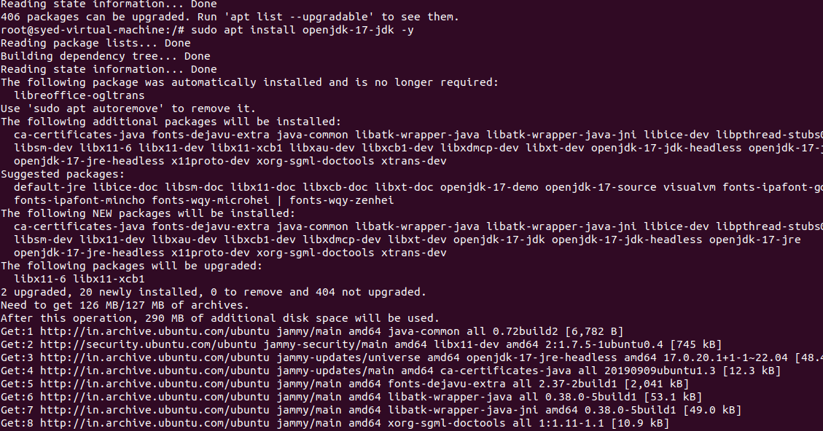

4. Download Apache Tomcat
Install the required tools:
sudo apt install curl tar -y
Create a directory for Tomcat:
sudo mkdir -p /opt/tomcat
Download and extract Tomcat 10:
cd /tmp
curl -fLO https://dlcdn.apache.org/tomcat/tomcat-10/v10.1.61/bin/apache-tomcat-10.1.61.tar.gz
we need to install this using command:
wget https://dlcdn.apache.org/tomcat/tomcat-10/v10.1.61/bin/apache-tomcat-10.1.61.tar.gz
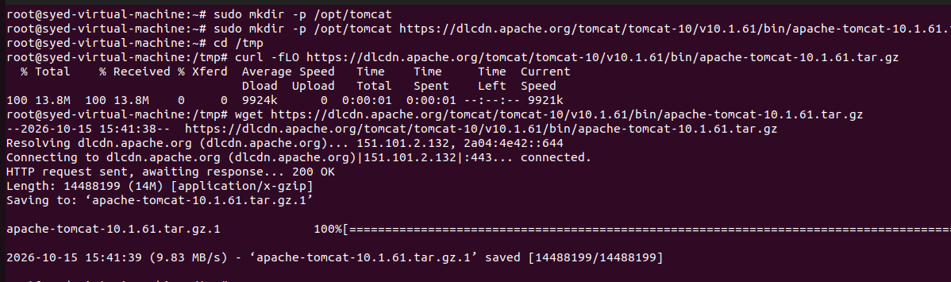
sudo tar -xzf apache-tomcat-10.1.49.tar.gz -C /tem/tomcat --strip-components=1

If the download URL is unavailable, use a current supported Tomcat 10.1 release from the official Apache Tomcat download page: https://tomcat.apache.org/download-10.cgi

5. Set Permissions for Tomcat
sudo chmod +x /opt/tomcat/bin/*.sh
Verify that the Tomcat files exist:
ls /opt/tomcat
You should see directories such as bin, conf, lib, logs, webapps and work.

6. Configure Tomcat to Use Port 8082
Open the Tomcat server configuration file:
sudo nano /opt/tomcat/conf/server.xml
Find the HTTP Connector line, which normally contains port 8080:
<Connector port="8080" protocol="HTTP/1.1"
connectionTimeout="20000"
redirectPort="8443" />
Change the port from 8080 to 8082:
<Connector port="8082" protocol="HTTP/1.1"
connectionTimeout="20000"
redirectPort="8443" />
Save and exit Nano: press Ctrl + O to save, press Enter to confirm, then press Ctrl + X to exit.
Important: Change the existing HTTP Connector. Do not add a second connector unnecessarily.
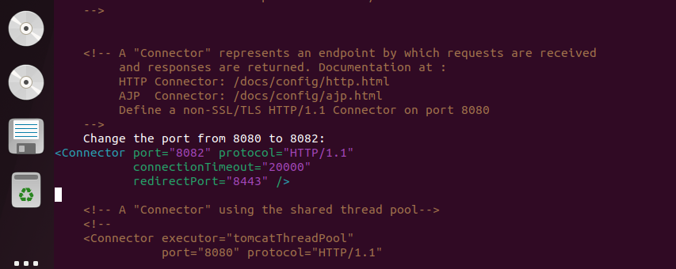

7. Start Apache Tomcat
Start Tomcat using the startup script:
sudo /opt/tomcat/bin/startup.sh
Expected output should indicate that Tomcat has started.

8. Verify Tomcat Is Listening on Port 8082
Run:
sudo ss -lntp | grep ':8082'
If Tomcat is running correctly, you should see a listening entry for port 8082.
Check the response locally:
curl -I http://localhost:8082
A successful response commonly shows:
HTTP/1.1 200
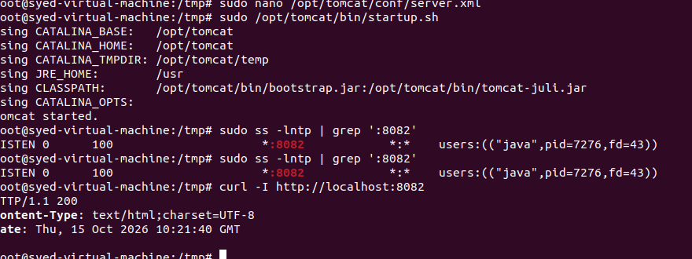

9. Open the Tomcat Web Page
Open Firefox in Ubuntu and enter:
http:// 192.168.2.128:8082
Expected result: The Apache Tomcat welcome page should appear.
If you are accessing Tomcat from another computer, use the Ubuntu server IP address:
http://SERVER_IP:8082
Replace SERVER_IP with your Ubuntu server’s actual IP address. To find the IP address, run:
hostname -I
If you are using an AWS EC2 instance, also allow inbound TCP port 8082 in its security group, preferably only from your own IP address.

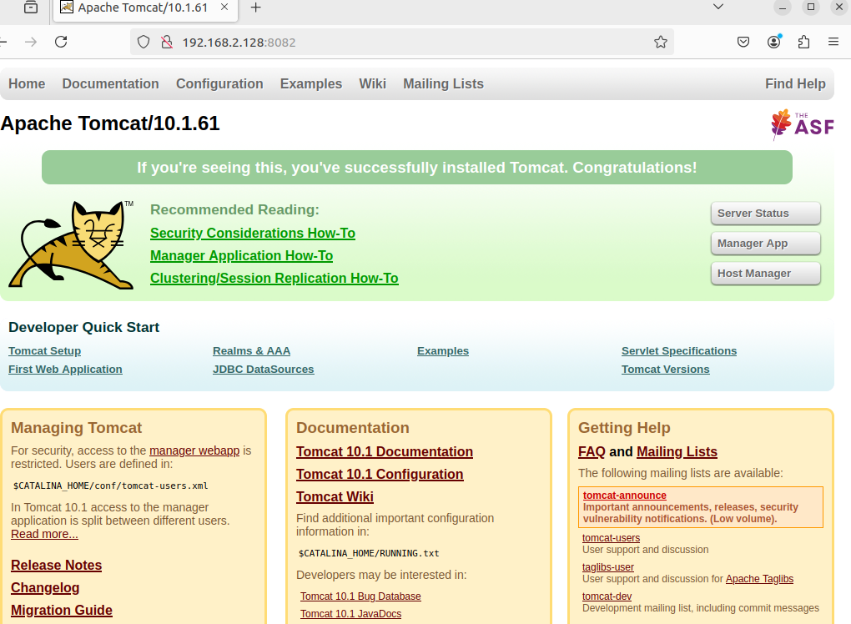

Outcome
Successfully installed Apache Tomcat on Ubuntu, configured its HTTP Connector to use port 8082, started the server, and verified that the Tomcat web page is accessible through a browser.

